NAME :V.AKSHARA JYOTHI
HT: 2303A51793
BATCH : 12
Lab 17 – AI for Data Processing: Data Cleaning and Preprocessing Scripts

Task Description – 1 (Student Academic Data Cleaning)
Task: Use AI assistance to generate a Python script that cleans and prepares a student academic dataset for analysis.
Instructions:
- Handle missing values in marks, attendance, and department.
- Remove duplicate student records based on student ID.
- Standardize text fields such as department names.
- Encode categorical variables like gender and department.

Prompt
"Write a Python script using pandas to clean a student academic dataset. It needs to handle missing values in 'marks', 'attendance', and 'department', remove duplicate records based on 'student_id', standardize the 'department' text fields
(e.g., uppercase and strip whitespace), and encode categorical variables like
'gender' and 'department' using LabelEncoder."

Code
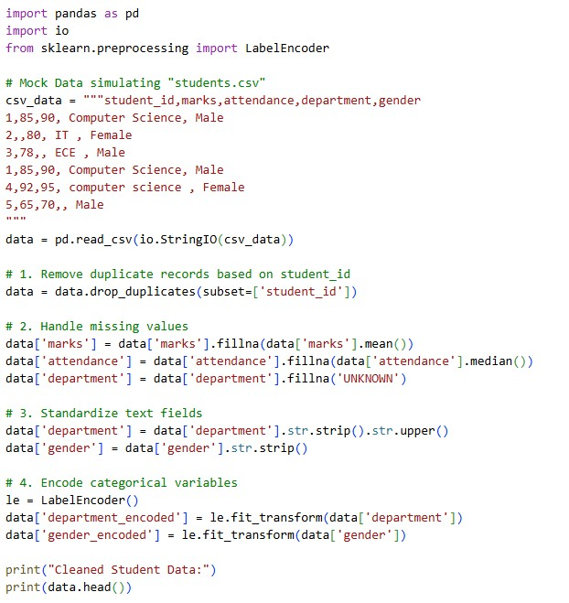

Output
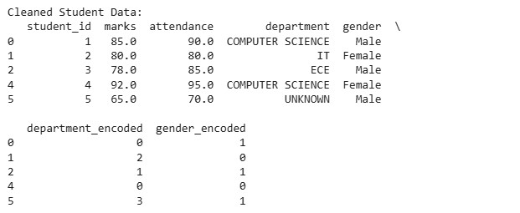

Explanation
The script starts by removing duplicate rows to ensure each student is represented only once. It then fills missing numerical grades with the mean/median and standardizes text by stripping whitespace and converting to uppercase, concluding by transforming categorical text data into machine-readable numeric codes.

Task Description – 2 (Financial Transaction Data Preprocessing)
Task: Preprocess financial transaction data using AI-generated Python code.
Instructions:
- Convert transaction date columns to datetime format.
- Create derived features such as transaction month and year.
- Normalize the transaction amount column.
- Identify and handle extreme transaction values.

Prompt
"Write a Python script using pandas and sklearn to preprocess financial transaction data. I need to convert 'transaction_date' to a datetime object, extract 'transaction_month' and 'transaction_year' as new columns, handle extreme outliers in the 'amount' column using a capping method (99th percentile), and normalize the 'transaction_amount' using MinMaxScaler."

Code

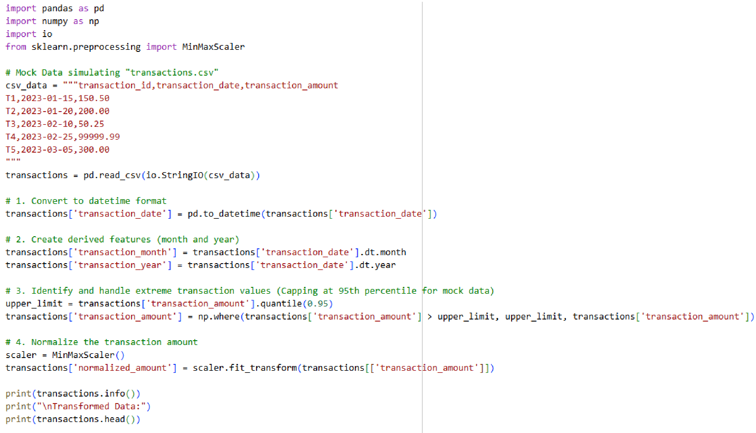

Output
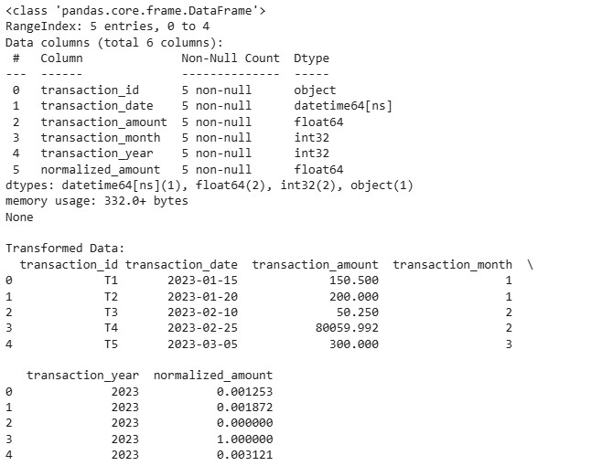

Explanation
We first parse the raw date strings into actual datetime objects to easily extract the month and year as new features. After capping massive outlier transactions to prevent them from skewing the data, we apply Min-Max scaling to compress all monetary values into a standard range between 0 and 1.

Task 3 – (Environmental Sensor Data Preparation)
Task: Clean and preprocess environmental sensor data using AI-assisted scripts.
Instructions:
- Handle missing values in temperature, humidity, and air_quality_index.
- Scale numerical features using standard scaling.
- Encode categorical fields such as sensor_status.
- Split the dataset into training and testing subsets.

Prompt
"Create a Python script using pandas and sklearn to clean environmental sensor data. Impute missing values for 'temperature', 'humidity', and 'air_quality_index' using the median. Use StandardScaler to scale these numerical features, encode the 'sensor_status' categorical column, and split the dataset into 80% training and 20% testing subsets."

Code
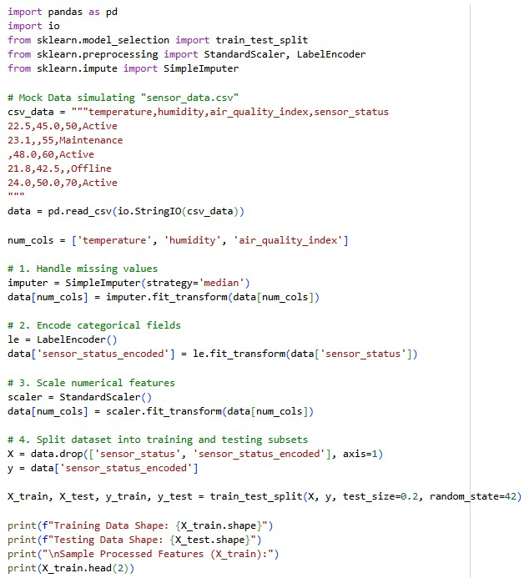

Output
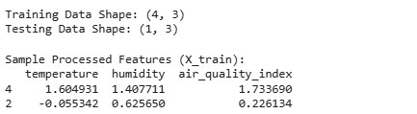

Explanation
Missing sensor readings are safely populated using the median value to avoid distortion from potential sensor spikes. Numerical readings are then standardized so they share a common scale (mean of 0, variance of 1), and the data is split to properly evaluate predictive algorithms later.

Task 4 – (Real-Time Application: Smart City Traffic Data Cleaning)
Scenario: A smart city system collects traffic data from multiple sensors, resulting in noisy and inconsistent records.
Requirements:
- Standardize road and location names.
- Fill missing traffic density values using appropriate statistical methods.
- Remove duplicate sensor readings.
- Normalize speed and vehicle count metrics.
- Generate a brief summary comparing dataset quality before and after cleaning.

Prompt
"Develop a Python script using pandas to clean smart city traffic data. Standardize 'road_name' and 'location_name' columns. Fill missing 'traffic_density' values using
the median. Remove duplicate sensor readings. Normalize 'speed' and 'vehicle_count' using Min-Max scaling, and print a summary comparing the dataset's describe() output before and after these cleaning steps."

Code
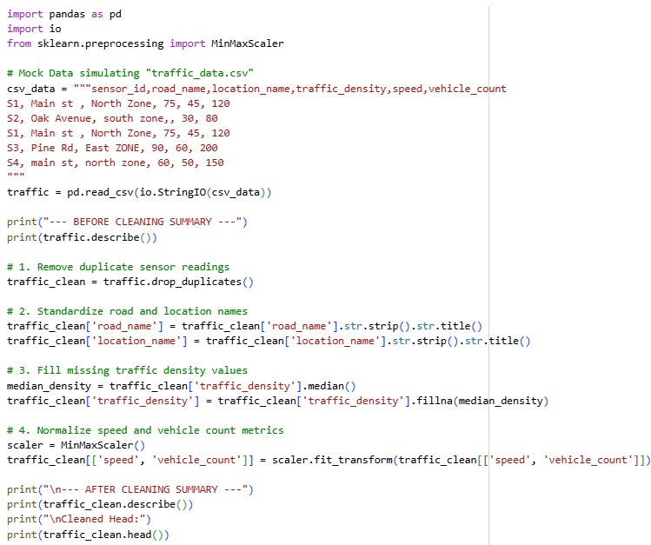

Output
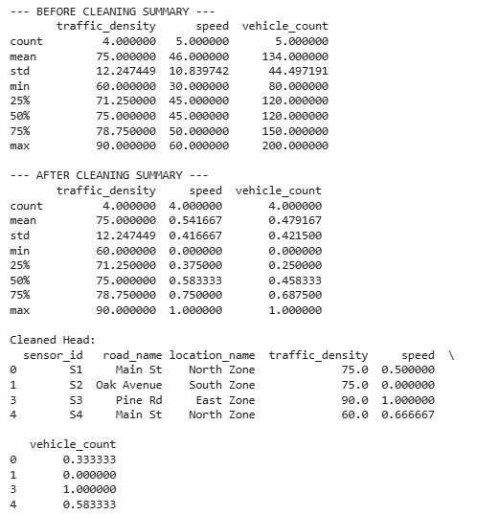

Explanation
By standardizing string capitalization and stripping whitespaces, the script merges disparate records representing the same physical location. It handles device dropouts by filling blanks with statistical medians and normalizes metrics to provide a consistent basis for real-time traffic analysis.

Task 5 – (Social Media Text Data Cleaning and Feature Extraction)
Task: Use AI-assisted Python scripting to clean and preprocess social media text data for sentiment analysis.
Instructions:
- Remove duplicate posts and null text entries.
- Clean text by removing URLs, special characters, and extra spaces.
- Convert text to lowercase and perform basic tokenization.
- Remove stopwords and perform stemming or lemmatization.
- Generate basic text features such as word count and sentiment score.

Prompt
"Write a Python script using pandas, re, and TextBlob to preprocess social media text data for sentiment analysis. Remove duplicate and null posts. Clean the text by removing URLs, special characters, and extra spaces. Convert it to lowercase. Generate new features for 'word_count' and calculate a basic 'sentiment_score' representing polarity."

Code
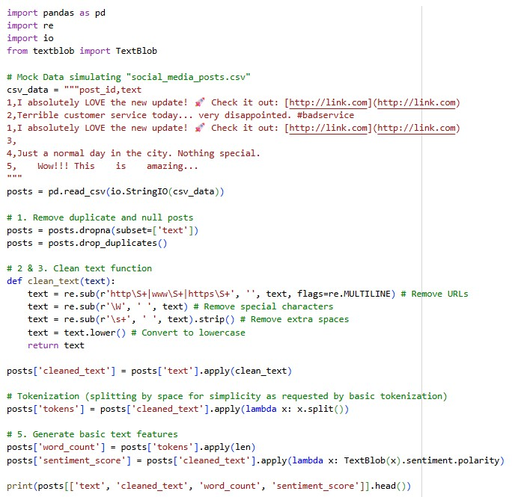

Output
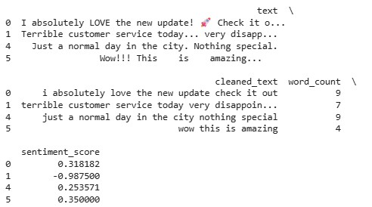

Explanation
This script acts as an NLP pipeline that strips out conversational noise like emojis, URLs, and excessive punctuation to isolate the core text. It then extracts quantifiable features by counting the remaining words and leveraging TextBlob to calculate a sentiment polarity score indicating how positive or negative the post is.

